ORIGINATOR:
Name | Department | Signature | Date
Brian Cullinan | Software Developer

APPROVALS
Name | Department | Signature | Date
Scott Pletzer | Director of Quality & Program Management
Andrew Mason | Chief Technology Officer

REVISION HISTORY
Revision | Revision Date | Reason for Revision/Change Request | Revised By
000 | 08AUG12 | Initial Release | S. Pletzer

- Purpose

This document is intended to provide a protocol for use in verifying and validating EPIC ClearView Synchronizer Version 1.0 (Synchronizer). This protocol is intended to provide a method for conducting the testing as well as to be used as a formal record of the validation activities.

- Scope

This protocol is intended to be used to test Synchronizer to confirm the requirements of SR-005, EPIC ClearView Synchronizer Requirements. Where appropriate in Section 6.0 below, references to the corresponding requirement(s) from SR-005 are included.

- Definitions

N/A

- Responsibilities

User | - Complies with the policy and procedure.  - Ensures the most current version of this document is used when referenced.
Departmental Management | - Ensures departmental personnel are properly trained before using this policy or procedure.  - Provides oversight to the validation process and ensures that all quality system requirements are met.
Quality Assurance | - Monitors the implementation and effectiveness of this document.  - Audits to ensure compliance with the referenced procedures

- Policy

  - This protocol is intended to be updated for any changes made to Synchronizer such that the instructions provide a comprehensive test to demonstrate whether it meets the intended use.
  - Follow the instructions provided within this protocol as written. Any deviations from the written protocol will be recorded on Attachment A, Deviations from Protocol.

    - An individual will be assigned responsibility from the Validation Team to oversee the execution of the protocol. This validation designee will review each deviation as documented prior to moving forward in the validation process.
    - The validation designee will be required to determine whether the deviation requires formal documentation through EPIC’s Deviation procedure or if the deviation is minor enough to warrant documentation only.
    - Upon completion of the protocol, the Validation Team has the responsibility to review all deviations recorded to determine whether or not they significantly impact the protocol/validation process. Any deviation deemed significant will be handled through EPIC’s Deviations procedure.
    - The individual performing the validation protocol will complete each column of Attachment A for all deviations from the written protocol prior to moving forward. The validation designee will review each deviation prior to moving forward in the validation process. This review is indicated by documenting a signature and date in the Review column of the Deviations from Protocol worksheet located in Attachment A.
    - The validation designee should be aware during the execution of this validation protocol that the intention is to validate all functionality of Synchronizer. If at any time a portion of Synchronizer is identified as not being challenged, notify the validation team immediately and document the omission on the non-conformances worksheet.

  - The written protocol is intended to capture the steps needed to properly challenge each Synchronizer function. However, given the evolving nature of Synchronizer and software development, the instructions may not be 100% accurate. Therefore, any minor deviation from the written instructions will be corrected in writing during the execution of the validation protocol. These corrections will be reviewed by QA as a part of the validation analysis. The review will determine appropriate corrective and preventive action for any deviations notes.

  - Record the results of each validation step by initialing and dating in the space provided. If the characteristic cannot be verified, record a reference number on the protocol and the Non-Conformances Worksheet (Attachment B) and describe the failure in a specific and complete manner by completing all columns on the Non-Conformance Worksheet. Some validation steps ask the validation designee to record the results side-by-side. In these cases, record initials and date on each side of the slash mark after validating each step as instructed.

  - All verification and/or validation documentation created will be labeled with the version number, the Sample # (indicated in the protocol) and the initials and date of the individual performing the verification/validation step.

- Procedure
  - Start Synchronizer and confirm Administrative privileges are required. Windows will ask to confirm if you are sure you want to run this application, an administrative password is required for non-administrator accounts. Confirm that an icon appears in the Windows tray:
NOTE: Reference SR-005 4.4, 4.4.1
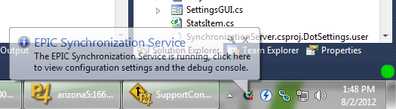
__________ Verified __________ Not Verified Non-Conform Ref #
  - Click the ClearView icon and confirm the configuration dialog appears. The icon may be hidden by Windows automatically, but can always be accessed by clicking the up-arrow left of the tray. e.g.:
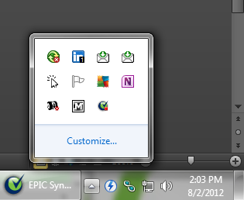
__________ Verified __________ Not Verified Non-Conform Ref #
  - Click Hide in the lower right corner and confirm the configuration dialog disappears and the tray icon remains.
__________ Verified __________ Not Verified Non-Conform Ref #
  - Reset the Configuration
NOTE: Reference SR-005 4.9, 4.15, 4.16, and 4.17
    - Open the configuration dialog by right-clicking the icon in the tray and selecting Show Dialog.
__________ Verified __________ Not Verified Non-Conform Ref #
    - Confirm the following settings are set:
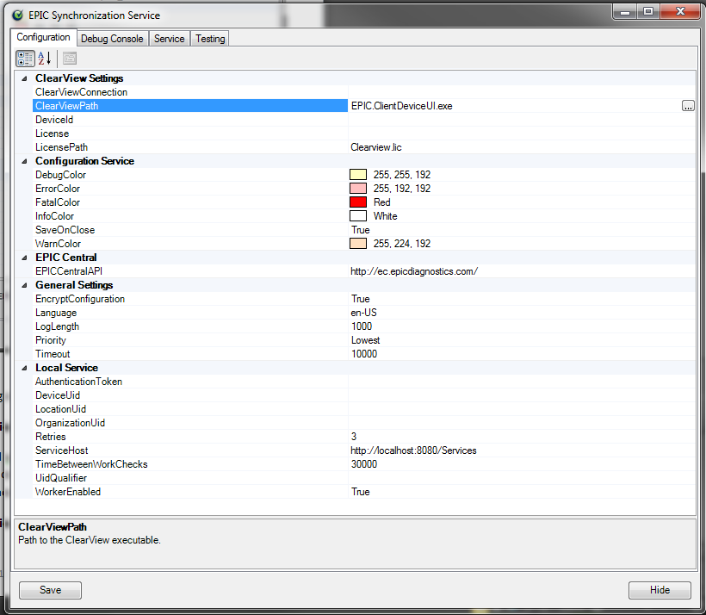
If a setting is not set correctly, change it to match the picture above. On at least one setting, right-click the setting in the left column and select “Reset”.
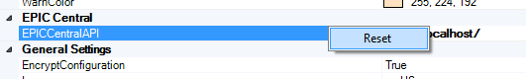
Not all settings allow the Reset option and will have to be cleared by selecting the text in the right column and clearing the text with the keyboard.
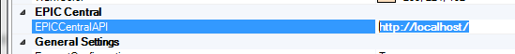
__________ Verified __________ Not Verified Non-Conform Ref #
  - Testing Tab
NOTE: Reference SR-005 4.8.1, 4.8.2, and 4.8.3
    - Click the Service tab and verify that the service is stopped, you may need to click Stop in order to get the service in to this state. Click the testing tab and verify the debug console and test buttons appear.
__________ Verified __________ Not Verified Non-Conform Ref #
    - Click each button on the bottom half and verify an entry in the debug console is added that reads “An exception occurred while connecting to Local service.” Other message dialogs and messages may appear and should be ignored by clicking Ok or Cancel.
__________ Verified __________ Not Verified Non-Conform Ref #
    - Click the Clear button in the bottom left and confirm the debug console is cleared.
__________ Verified __________ Not Verified Non-Conform Ref #
    - Select the “Service” tab at the top and click “Run”, if the Run button is disabled, Stop must be clicked before clicking Run.
__________ Verified __________ Not Verified Non-Conform Ref #
    - Select the Testing tab at the top and confirm that at least one message was added that begins with “Listening for ClearView connections”.
__________ Verified __________ Not Verified Non-Conform Ref #
    - Click each testing button and confirm that a message is added that begins with “Created http://tempuri.org/IServices/”. Save the “Simulate registration” button for last. Each button will have its own ending to that line. If the line cannot be seen, double-click the border between the column headings between Message and Level at the top of the grid. Other dialog messages may appear for different buttons, these should be ignored by clicking Ok or Cancel.
NOTE: Reference SR-005 4.2, 4.4.2, 4.4.3, 4.8, and 4.14
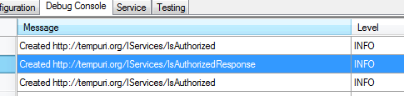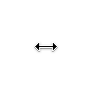
__________ Verified __________ Not Verified Non-Conform Ref #
  - Registration
NOTE: Reference SR-005 4.16
    - After clicking Simulate registration on the testing tab, a new dialog will appear. Fill it in as follows:
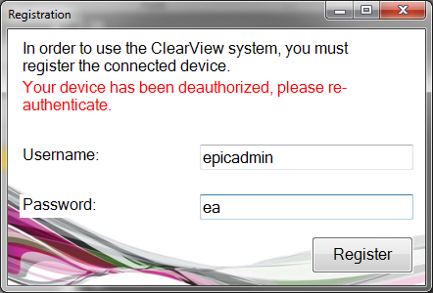
__________ Verified __________ Not Verified Non-Conform Ref #
    - Click Register and fill in the next part as follows:
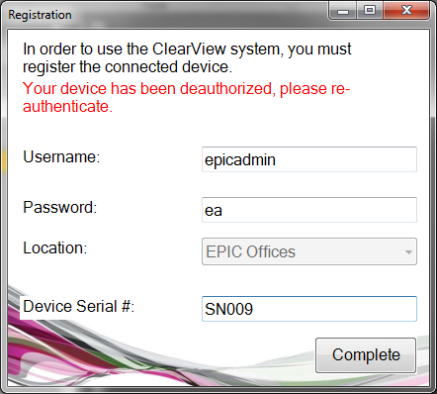
__________ Verified __________ Not Verified Non-Conform Ref #
    - Click complete and verify a message “Success!” appears and the dialog closes.
__________ Verified __________ Not Verified Non-Conform Ref #
  - Debug Console
    - The same list is displayed on the Testing tab as the Debug tab. Confirm that more details appear when a line is selected just like above. The bold heading should match the Level column.
__________ Verified __________ Not Verified Non-Conform Ref #
  - Configuration Tab
NOTE: Reference SR-005 4.12, 4.13
    - Confirm the following settings are now bolded and filled in after successfully completing the Registration step above.
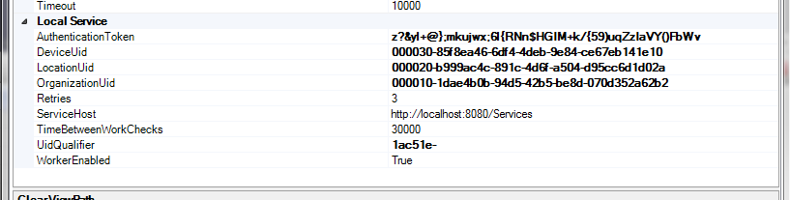
__________ Verified __________ Not Verified Non-Conform Ref #
    - Pick out different colors by clicking the drop down arrow in the right column and confirm they are effective by looking at the Debug tab. Some error types may not be displayed.
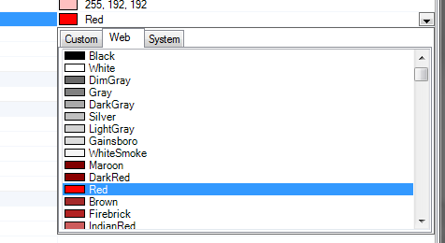
__________ Verified __________ Not Verified Non-Conform Ref #
    - Change the Language property by clicking the drop-down arrow on the right hand side and selecting a different language from the list. Click Save. Close the dialog. Re-open the dialog using the tray icon. Verify the language is different.
NOTE: Reference SR-005 4.5, 4.11
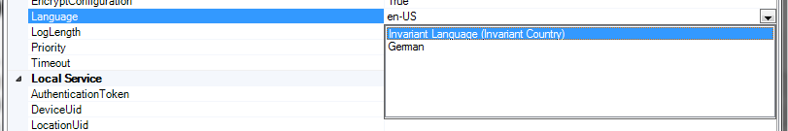
__________ Verified __________ Not Verified Non-Conform Ref #
    - Click the ellipsis “…” next to ClearView Path and select the path to ClearView. Verify the surrounding settings are filled in.
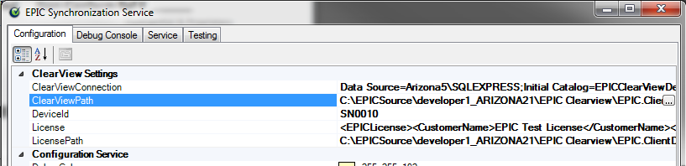
  - Service Tab
NOTE: Reference SR-005 4.1, 4.3, and 4.4.4
    - Select the Service tab and verify the synchronizer is in a “Stopped” state. You may need to click stop in order to get it to a stopped state. Click Start and verify the start button becomes disabled and the Stop button becomes available. This confirms the service is running as a standalone process.
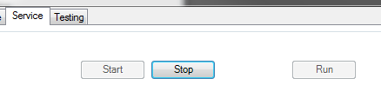
__________ Verified __________ Not Verified Non-Conform Ref #
    - Verify that when Simulate Exception Synchronize is clicked the count next to Exception Synchronized increases by 1.
NOTE: Reference SR-005 4.6, 4.7, and 4.10
__________ Verified __________ Not Verified Non-Conform Ref #

Attachment A
Deviations from Protocol
NOTE: This form is used for minor deviations from the protocol as written. Fill out all sections of this form prior to moving forward in the validation process.

No. | Date | Name | Description of Deviation (include reference to the protocol section) | Resolution/Action Taken | Reviewed

Attachment B

Non-conformances Worksheet
NOTE: This form is used for all protocol steps which did not perform as expected. Fill out all sections of this form prior to moving forward in the validation process.
No. | Date | Name | Description of Non-conformance (include reference to the protocol section) | Resolution/Action Taken

